**EDUCATION MANAGEMENT SYSTEM**

# **Introduction:**

The Education Management System is a centralized system for different schools which manages overall performance of specific school and average percentage of marks scored by the students in particular schools. This document provides a detailed design of the system. It starts with the design principle used, lists the non-functional requirements and a detail description about the subsystem or components which comprise the system and their interactions.

**System Architecture**:

The Education Management System can be divided into following systems.

* The school system where the user creates student and enter the marks for them.
* The RabbitMQ combines separate school data into a centralized system.
* The Education board system where the user can view the overall performance of the specific school.

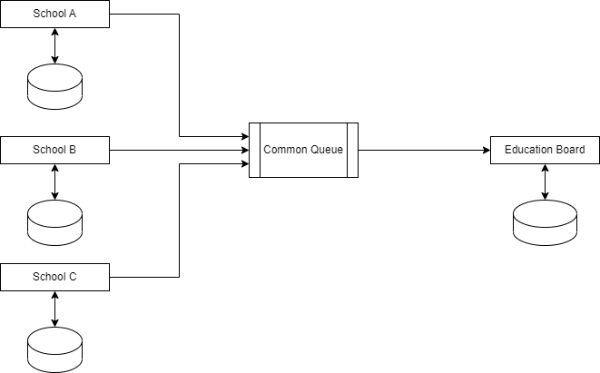

Database Diagram:

